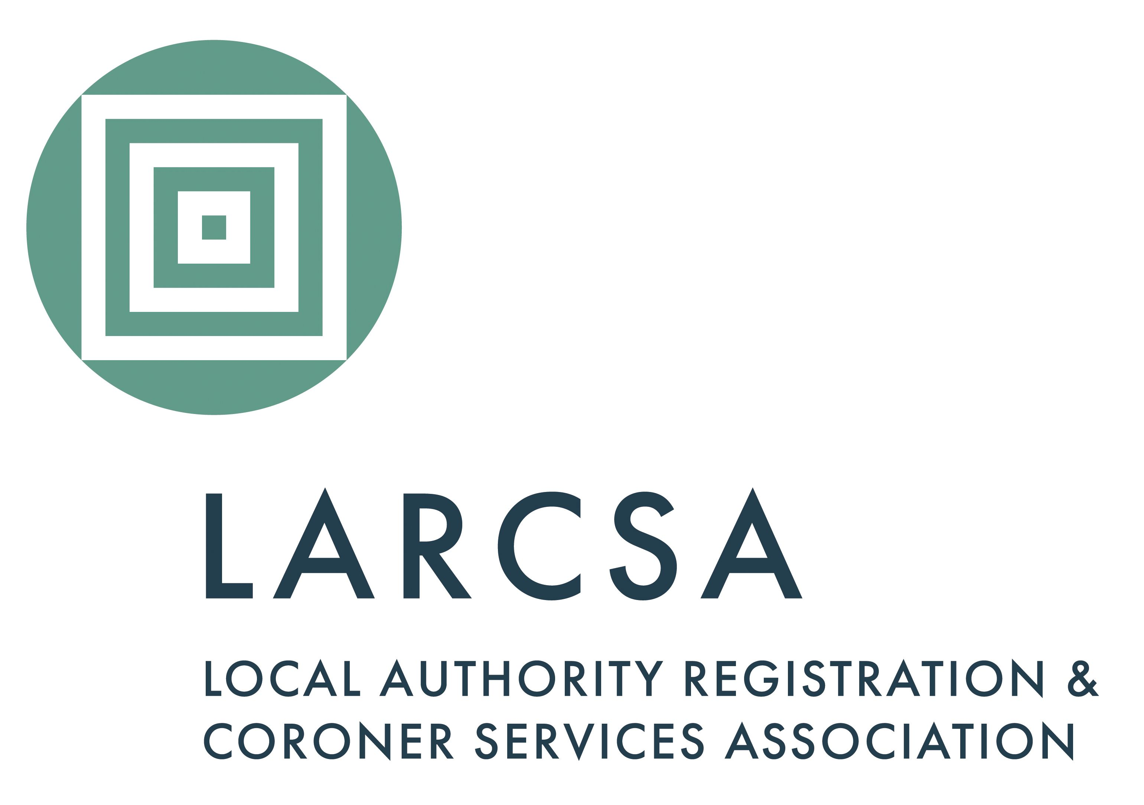Local Authority Registration and Coroner Services Association

1 Sylvan Court, Sylvan Way

Southfields Business Park

Basildon, Essex SS15 6TH

Email: [admin@larcsa.org.uk](mailto:admin@larcsa.org.uk)

**Application for Membership 2024/25**

£400 + VAT per annum for local authorities with a gross expenditure in excess of £600k. The subscription for Local Authorities with a gross expenditure of less than £600k is £300+VAT. The membership year runs from 1 April to 31 March. (Expenditure relates to the Registration Service).

|  |  |  |  |
| --- | --- | --- | --- |
| Authority | |  | |
| Authority Address | |  | |
| **General Office Contact Details** | | | |
| Address | |  | |
| Telephone number | |  | |
| Email address | |  | |
| **Primary Contact** | | | |
| Name (including title) | |  | |
| Telephone number | |  | |
| Mobile number | |  | |
| Email address | |  | |
| Job Title | |  | |
| **Second Contact** | | | |
| Name (including title) | |  | |
| Telephone number | |  | |
| Mobile number | |  | |
| Email address | |  | |
| Job Title | |  | |
| **Third Contact** | | | |
| Name (including title) | |  | |
| Telephone number | |  | |
| Mobile number | |  | |
| Email address | |  | |
| Job Title | |  | |
| Please note: If there are more than three contacts that would like a log in to the LARCSA website, LARCSA can provide a general log in to all staff via a generic email address, supplied by you in the *'general office contact details'* section. | | | |
| **Purchase order number** | | |  |
| (Please be aware that your application will NOT be accepted without it) | | | |
| **Completed forms are to be returned to:** | | | |
| **Email:** | [admin@larcsa.org.uk](mailto:admin@larcsa.org.uk) | | |
| **Post:** | LARCSA, 1 Sylvan Court, Sylvan Way, Southfields Business Park, Basildon, Essex, SS15 6TH | | |